Scenario 3: Can we attach the static public Ip to another instance?
Yes, we can remap the elastic to another instance.
In the scenario, elastic Ip is attached to Linux server, lets attach this to windows server.
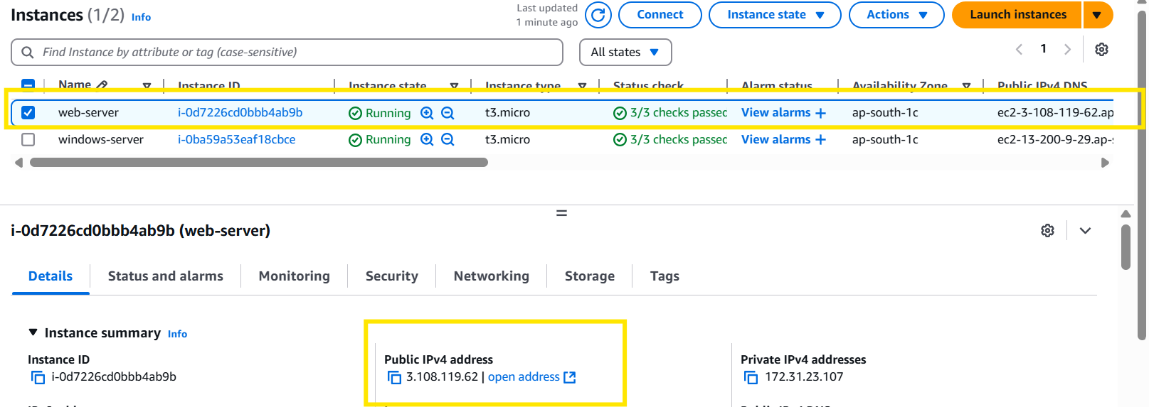
Let’s add public to windows server.
Step 1: Ec2 >scroll down to network & security and click on elastic Ip.
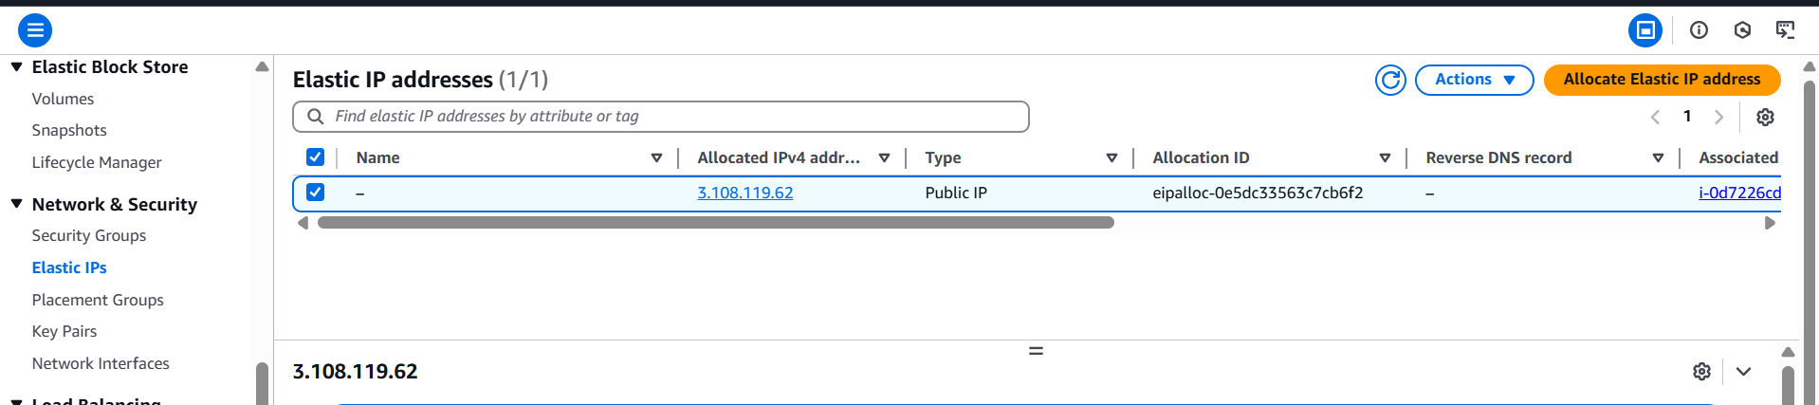
Step 2: select the IP and click on Actions > select disassociate IP.
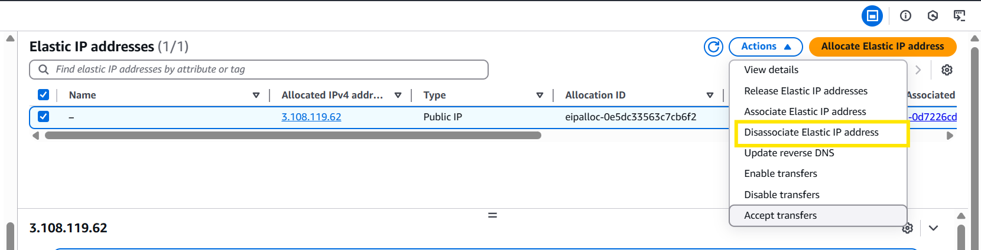
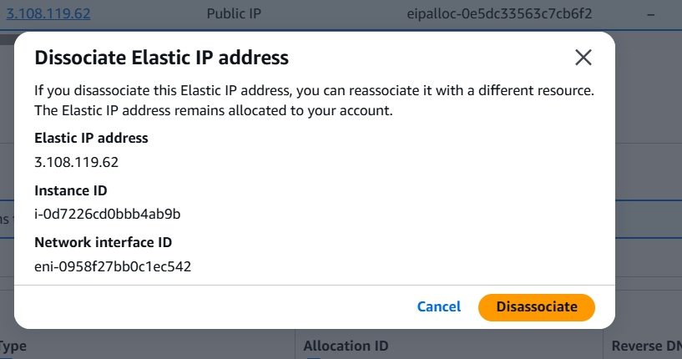
Step 3: Let’s validate in web-server, whether do we have the same Ip or its changed.
Now we could see that its changed
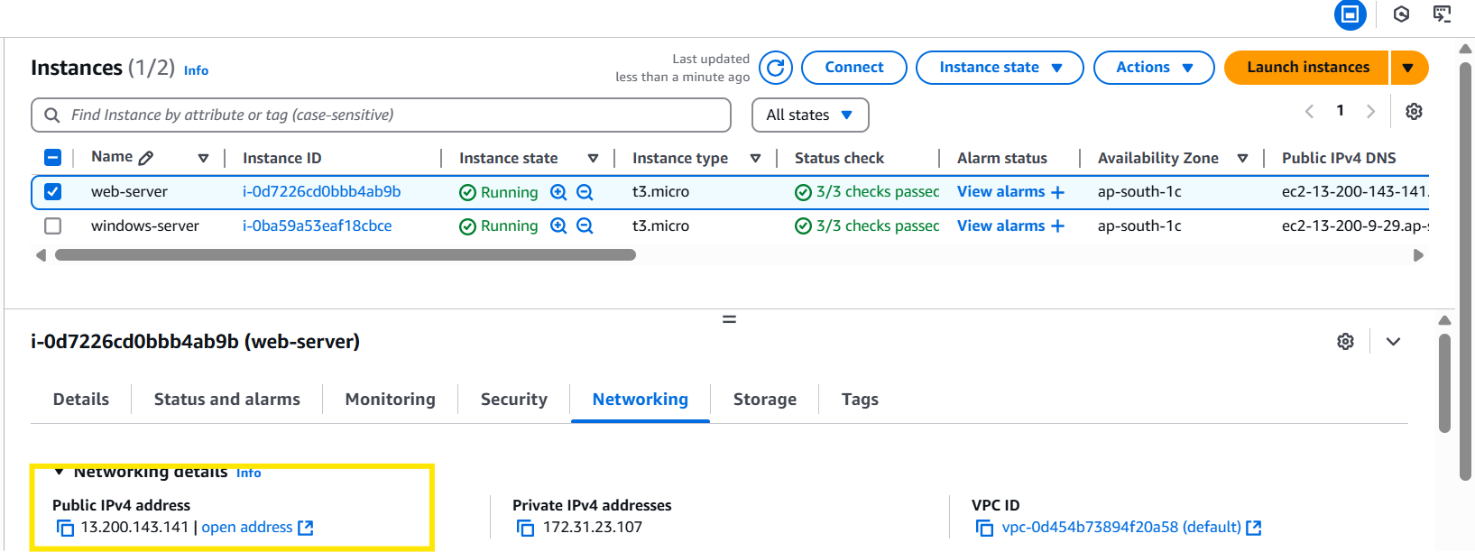
Step 4: lets associate the elastic Ip to Windows-server.
Select the elastic IP > actions > Associate Elastic IP address.
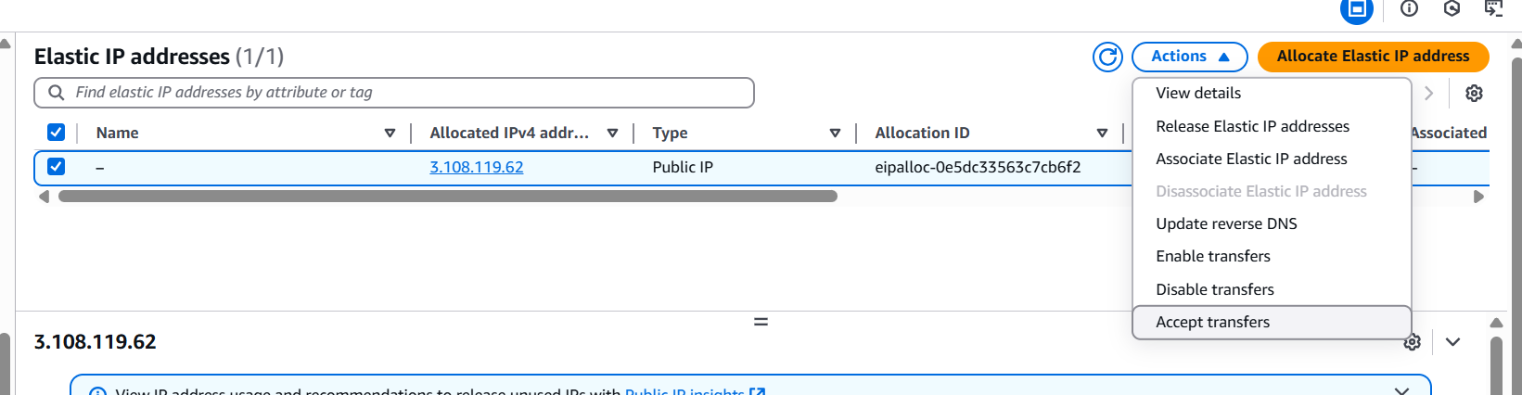

Step 5: select the windows server instance id , private Ip address and check the “Allow this Elastic IP address to be reassociated”
And click on associate.
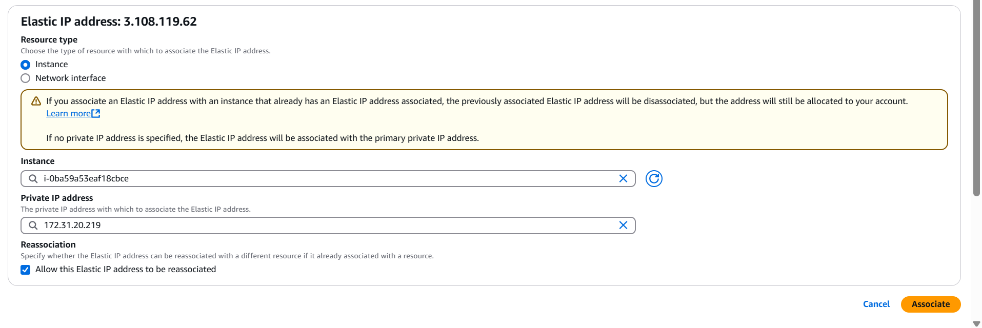
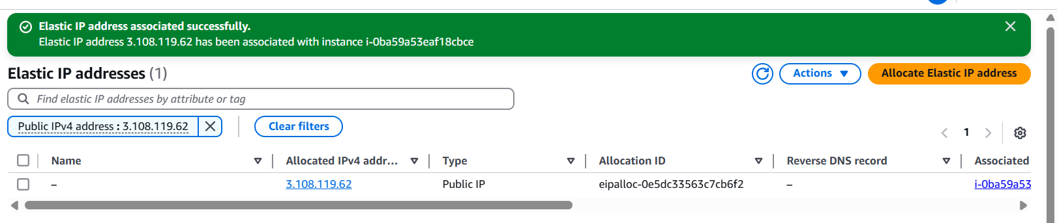
Step 6: Validate in the windows server instance
We could see that it’s been updated.
